**//WAP in Joomla to Create Menus**

Step 1 - In the main menu, click on Menus.

Click on the + sign next to the site item where you want to add the menu item. Otherwise, at the top of the page, click on +New to open the new menu item interface.

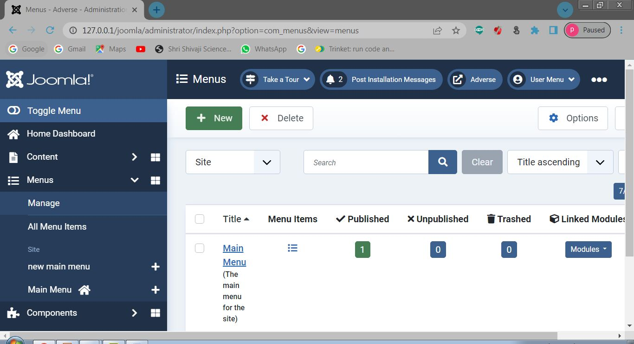

Step 2 - In the main menu, click on Menus. When the new menu item interface appears, make sure to give the item a title.

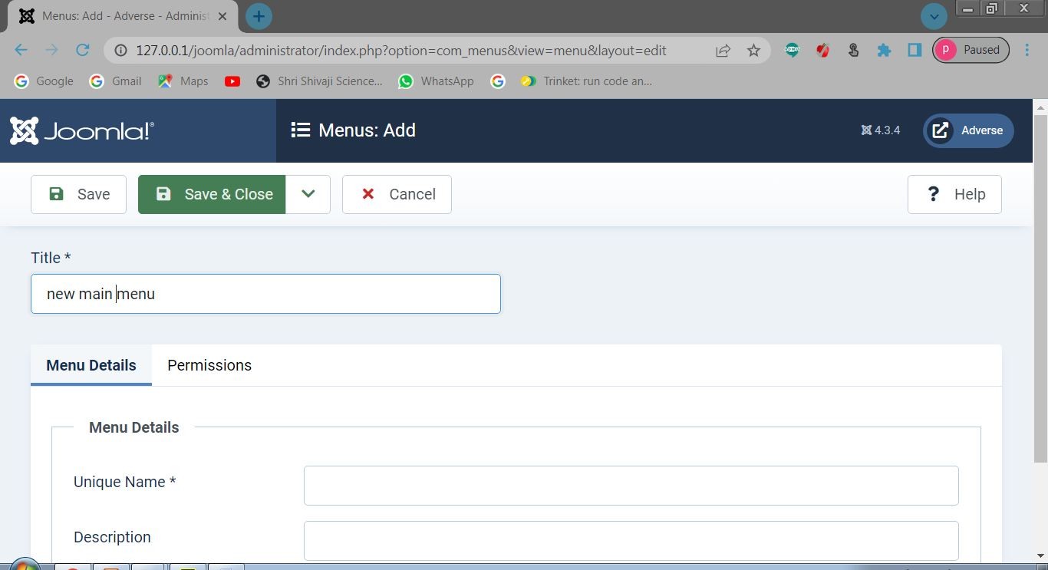

Step 3 - That next item that you need to fill is the Menu Item Type.

you can select Articles > Create Article.

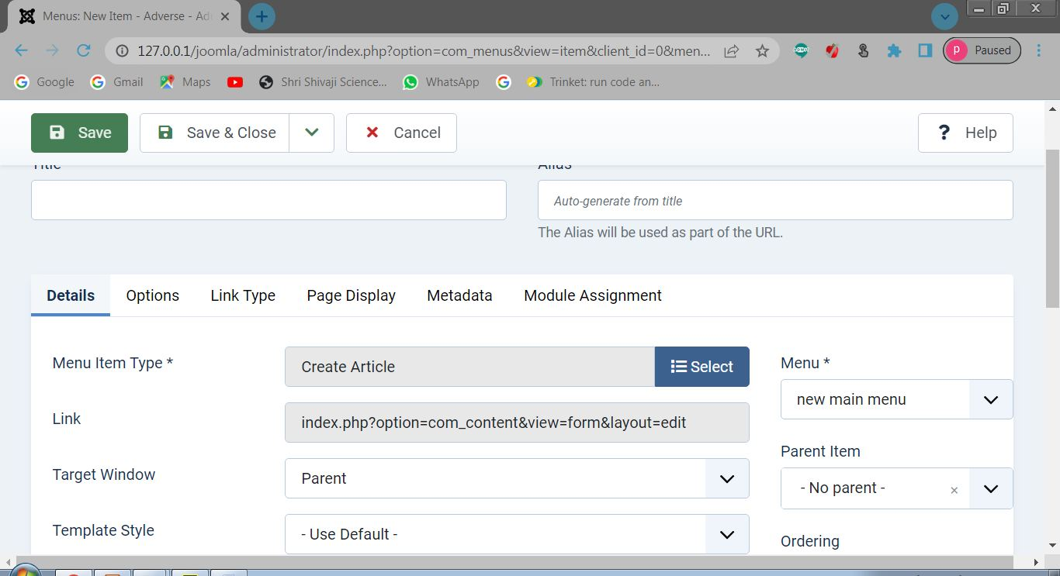

Step 4 - Adding Menu

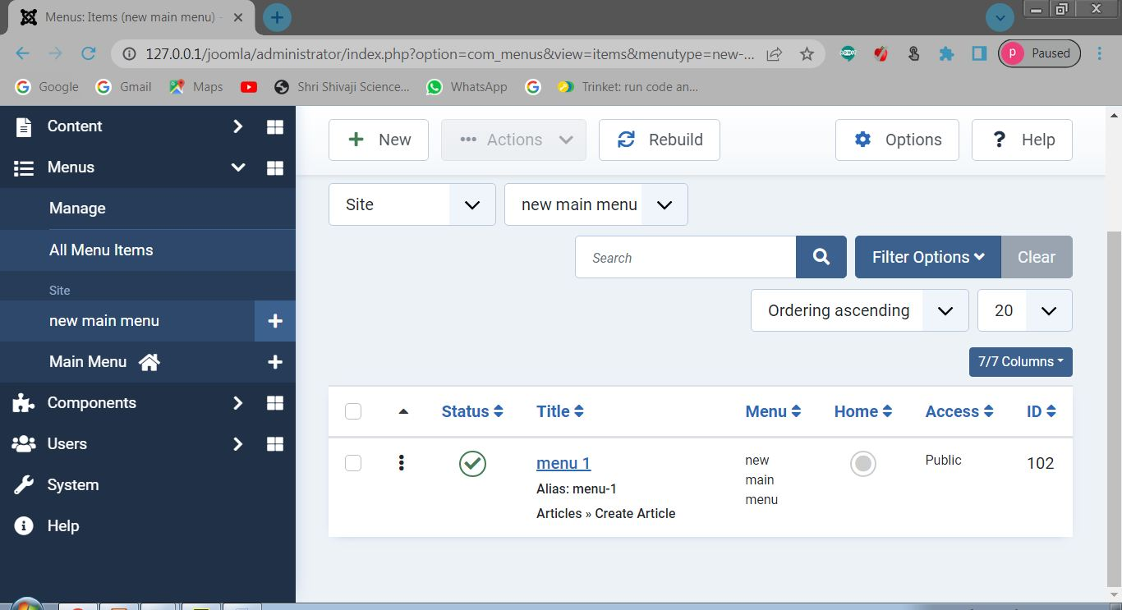

Step 7- Front End (Menu Created)

